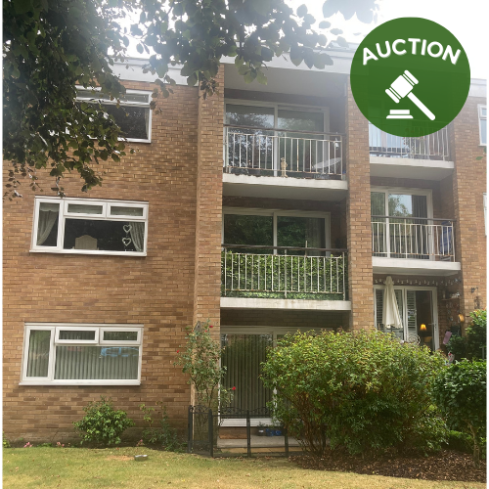

Auction Sale

64 Kenyon Road
Wigan
WN1 2DQ
www.ruttergreen.co.uk
hello@ruttergreen.co.uk
01942 367915

Flat 6, St Ives Court, Prenton CH43 8TR.
Auction Guide Price: £77,000
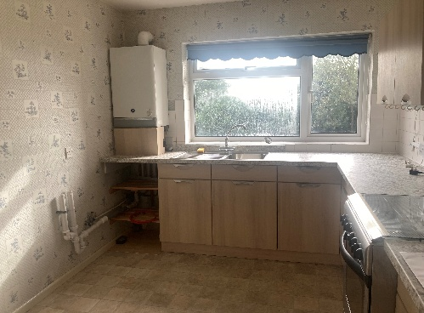
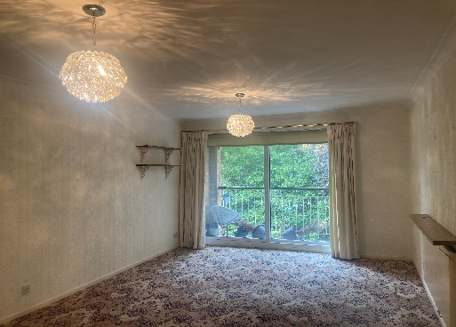
Flat 6, St Ives Court, Prenton CH43 8TR.
Two-Bedroom Apartment – St Ives Court, Forest Road, Prenton
- To be Sold via Online Auction
- Two Bedroom Apartment
- Located On The Second Floor
- Open Plan Living and Dining Room
- Two Double Bedrooms
- Access to a Single Car Garage
- Walking Distance to Birkenhead Park
- No Onward Chain
- Close to Local Amenities
- Ideal Investment Opportunity

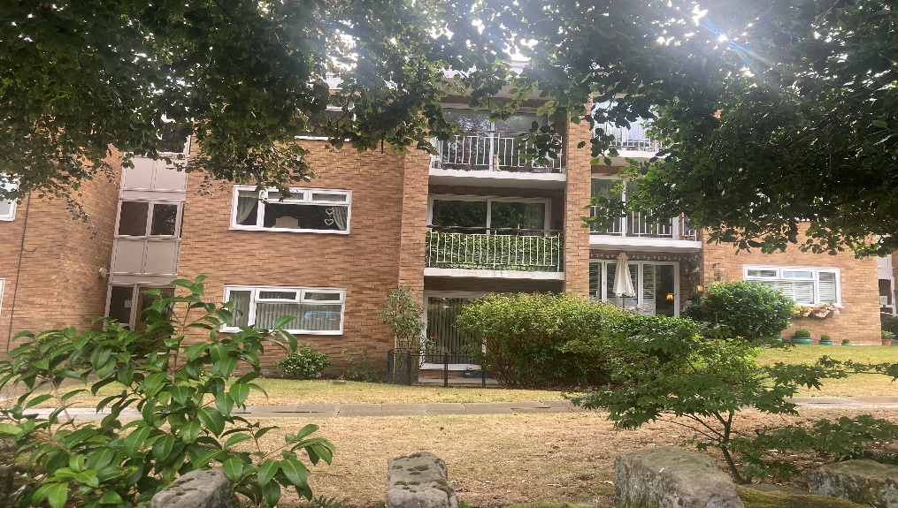
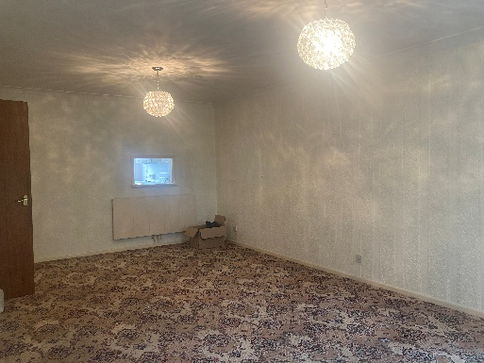
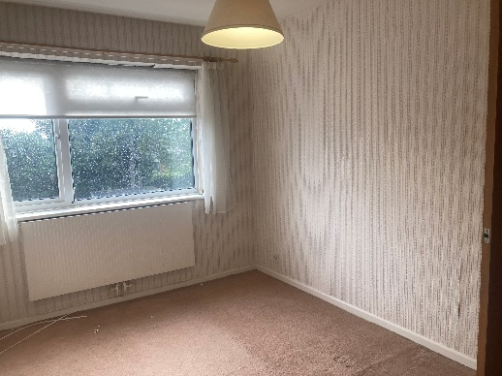
Welcome to this well-presented two-bedroom apartment located on the first floor of the popular St Ives Court development in Prenton.
Ideally positioned in a much desirable area, the property benefits from being close to a range of local amenities, excellent transport links, and the beautiful open spaces of Birkenhead Park, perfect for leisure and recreation.
The apartment offers a spacious lounge filled with natural light, complete with patio doors opening onto a private balcony making it an ideal spot to relax and unwind. The fitted kitchen is well equipped with a range of wall and base units, marble effect worktops and space for a small dining table, making it both functional and inviting. Two good sized bedrooms and a modern bathroom with walk in shower complete this well-maintained property. It also comes with a garage for a car or additional storage.
This property is being offered for sale via online auction and will be sold with vacant possession, presenting an excellent opportunity for both investors

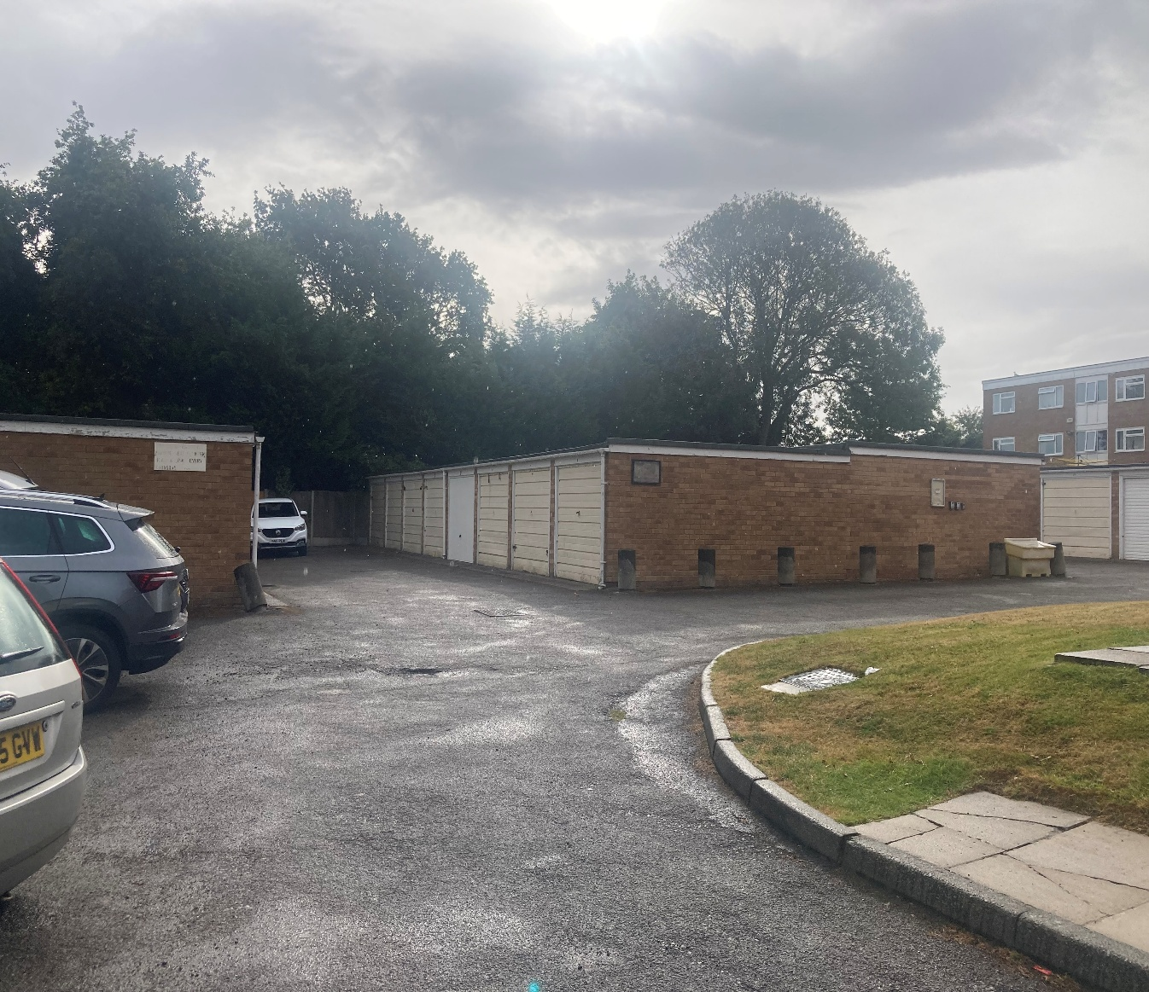

If you would like to arrange a viewing of this property, please contact our showroom at
64 Kenyon Road
Wigan
WN1 2DQ
01942 367915
hello@ruttergreen.co.uk
Additional information on this property is available at
www.ruttergreen.co.uk

Disclaimer
Although these particulars are thought to be materially correct, their accuracy cannot be guaranteed, and they do not form part of any contract. We ask our clients to check their own sales particulars and verify the information is correct. Fixtures, fittings and appliances have not been tested and therefore we can give no guarantees that they are in full working order. All measurements and land sizes are quoted approximately. Tenure should be established with your Solicitor and Council Tax band with Wigan Council.

